- Site Maps

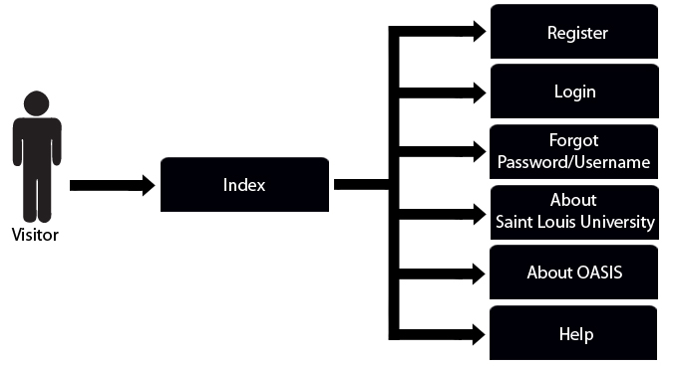
Figure 1 The image shown above is the OASIS visitor's site map.

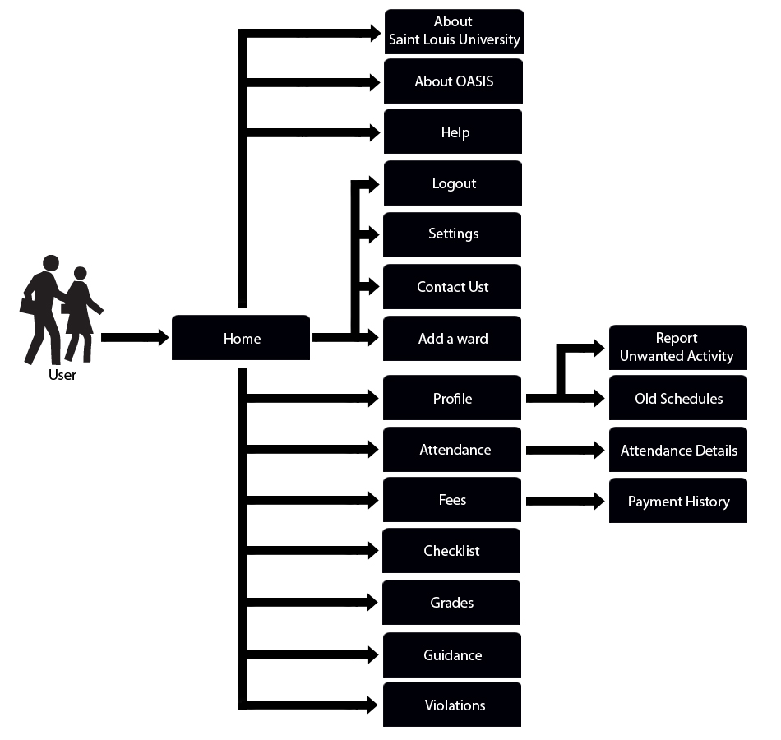

Figure 2 The image shown above is the OASIS user’s site map.

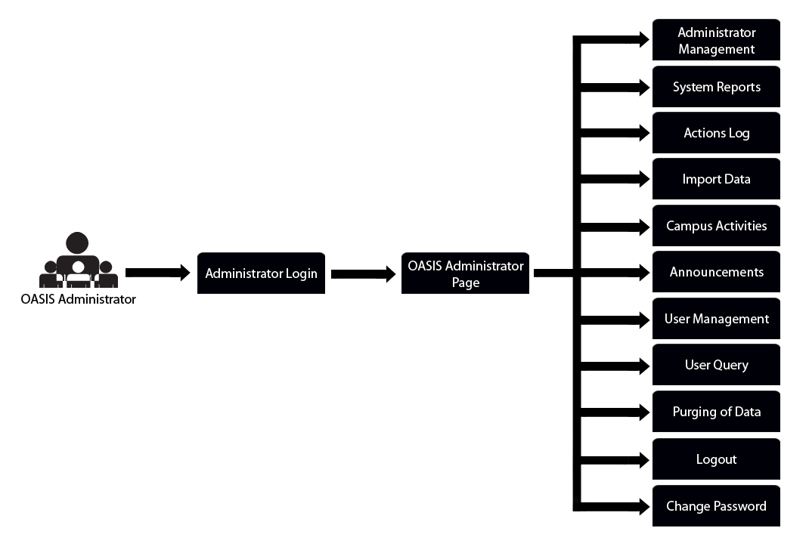
Figure 3 The image shown above is the OASIS Administrator's site map.

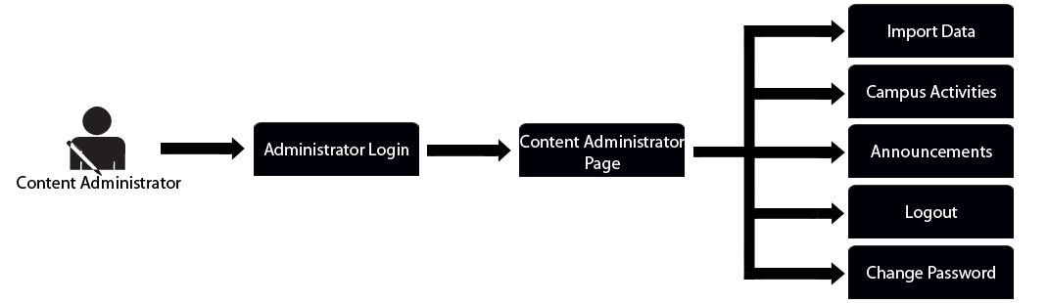
Figure 4 The image shown above is the Content Administrator's site map.

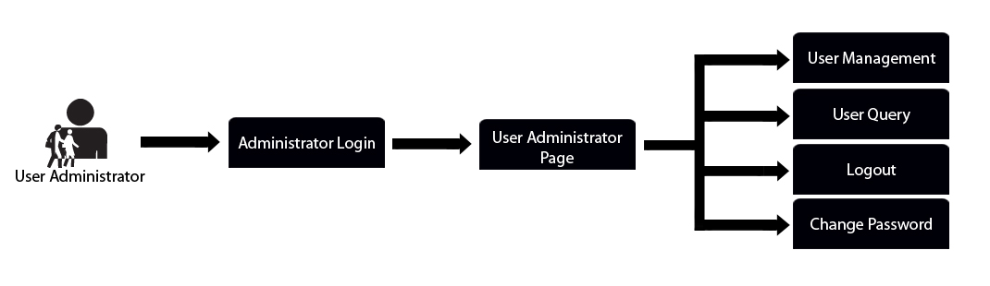
Figure 5 The image shown above is the User Administrator's site map.

